# SQL QUERIES

# ASSIGNMENT



## SUBMITTED BY:

PRIYA PAREKH

## SUBMITTED TO:

CHINMAYEE MAM

BACKEND DEVELOPMENT TOPS TECHNOLOGIES

1. Create Table Name: Student and Exam

Answer:

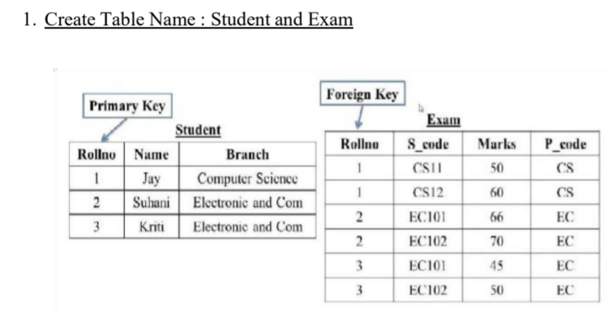

CREATE TABLE Student (

Rollno INT PRIMARY KEY,

Name VARCHAR(255),

Branch VARCHAR(255)

);

CREATE TABLE Exam (

Rollno INT,

S_code VARCHAR(255),

Marks INT,

P_code VARCHAR(255),

FOREIGN KEY (Rollno) REFERENCES Student(Rollno)

);

1. Create table given below: Employee and Incentive Table

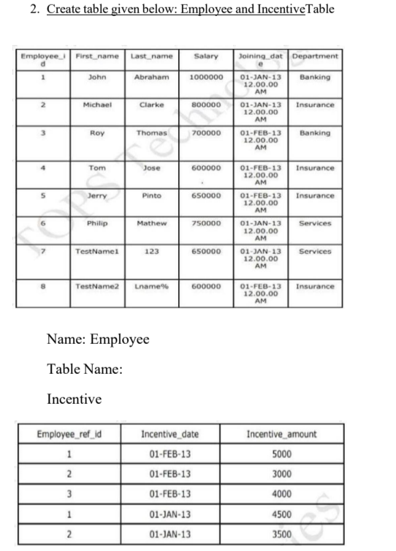

CREATE TABLE Employee (

Employee_id INT PRIMARY KEY,

First_name VARCHAR(255),

Last_name VARCHAR(255),

Salary INT,

Joining_date DATE,

Department VARCHAR(255)

);

INSERT INTO Employee (Employee_id, First_name, Last_name, Salary, Joining_date, Department) VALUES

(1, 'John', 'Abraham', 1000000, '2013-01-13', 'Banking'),

(2, 'Michael', 'Clarke', 800000, '2013-01-13', 'Insurance'),

(3, 'Roy', 'Thomas', 700000, '2013-02-13', 'Banking'),

(4, 'Tom', 'Jose', 600000, '2013-02-13', 'Insurance'),

(5, 'Jerry', 'Pinto', 650000, '2013-02-13', 'Insurance'),

(6, 'Philip', 'Mathew', 750000, '2013-01-13', 'Services'),

(7, 'TestName1', '123', 650000, '2013-01-13', 'Services'),

(8, 'TestName2', 'Lname%', 600000, '2013-02-13', 'Insurance');

CREATE TABLE Incentive (

Employee_ref_id INT,

Incentive_date DATE,

Incentive_amount INT

);

INSERT INTO Incentive (Employee_ref_id, Incentive_date, Incentive_amount) VALUES

(1, '2013-02-13', 5000),

(2, '2013-02-13', 3000),

(3, '2013-02-13', 4000),

(1, '2013-01-13', 4500),

1. Get First Name from the employee table using Tom name “Employee Name”.

Answer:

SELECT First_name

FROM Employee

WHERE Last_name = 'Jose';

4. Get FIRST_NAME, Joining Date, and Salary from employee table.

Answer:

SELECT

First_name,

Joining_dat,

Salary

FROM Employee;

1. Get all employee details from the employee table order by First_Name

Answer:

SELECT * FROM Employee ORDER BY First_name ASC, Salary DESC

6. Get employee details from the employee table whose first name contains ‘J’.

Answer:

SELECT *

FROM Employee

WHERE First_name LIKE '%J%';

7. Get department-wise maximum salary from employee table order by salary ascending.

Answer:

SELECT Department, MAX(Salary) AS MaxSalary

FROM Employee

GROUP BY Department

ORDER BY MaxSalary ASC;

8. Select first_name, incentive amount from the employee and incentives table

for those employees who have incentives and incentive amounts greater than 3000

Answer:

SELECT e.first_name, i.Incentive_amount

FROM Employee e

JOIN Incentive i ON

e.Employee_i_d = i.Employee_ref_id

WHERE i.Incentive_amount > 3000;

9. Create after Insert trigger on the Employee table which inserts records in

Viewable

Answer:

CREATE TRIGGER trg_Employee_Insert

AFTER INSERT ON Employee

AS

BEGIN

INSERT INTO Incentive (Employee_ref_id, Incentive_date, Incentive_amount)

SELECT i.Employee_id, GETDATE(), 5000

FROM inserted i;

END;

10. Create the table given below: Salesperson and Customer

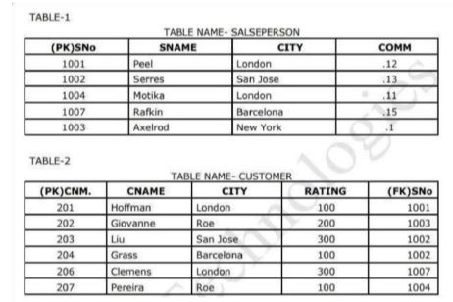

Answer:

CREATE TABLE Salesperson (

SNo INT PRIMARY KEY,

SNAME VARCHAR(255),

CITY VARCHAR(255),

COMM DECIMAL(4,2)

);

CREATE TABLE Customer (

CNM INT PRIMARY KEY,

CNAME VARCHAR(255),

CITY VARCHAR(255),

RATING INT,

SNo INT,

FOREIGN KEY (SNo) REFERENCES Salesperson(SNo)

);

INSERT INTO Salesperson (SNo, SNAME, CITY, COMM) VALUES

(1001, 'Peel', 'London', 0.12),

(1002, 'Serres', 'San Jose', 0.13),

(1004, 'Motika', 'London', 0.11),

(1007, 'Rafkin', 'Barcelona', 0.15),

(1003, 'Axelrod', 'New York', 0.1);

INSERT INTO Customer (CNM, CNAME, CITY, RATING, SNo) VALUES

(201, 'Hoffman', 'London', 100, 1001),

(202, 'Giovanne', 'Roe', 200, 1003),

(203, 'Liu', 'San Jose', 300, 1002),

(204, 'Grass', 'Barcelona', 100, 1002),

(206, 'Clemens', 'London', 300, 1007),

(207, 'Pereira', 'Roe', 100, 1004);

12. Retrieve the below data from the above table

Answer:

SELECT c.CNAME AS CustomerName, s.SNAME AS SalespersonName

FROM CUSTOMER c

JOIN SALESPERSONS ON c.SNo = s.SNo;

13. All orders for more than $1000.

Answer:

SELECT *

FROM Orders

WHERE amount > 1000;

14.Names and cities of all salespeople in London with commission above 0.1215.All salespeople either in Barcelona or in London

Answer:

SELECT SNAME, CITY

FROM SALESPERSON

WHERE CITY = 'London' AND COMM > 0.1215

UNION

SELECT SNAME, CITY

FROM SALESPERSON

WHERE CITY IN ('Barcelona', 'London');

16. All salespeople with a commission between 0.10 and 0.12. (Boundary values should be excluded).

Answer:

SELECT

CNAME,

CITY,

RATING,

SNAME

FROM CUSTOMER AS C

JOIN SALESPERSON AS S

ON C.(FK)SNo = S.SNo;

17. All customers excluding those with a rating <= 100 unless they are located

in Rome

Answer:

SELECT *

FROM Customer

WHERE RATING > 100

UNION

SELECT *

FROM Customer

WHERE CITY = 'Rome'

18. Write a SQL statement that displays all the information about all

Salespeople

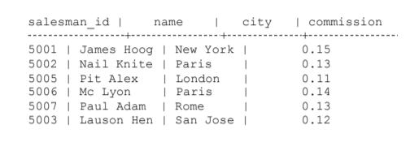

Answer:

SELECT *

FROM Salesperson;

19. From the following table, write a SQL query to find orders that a salesperson with ID delivers. 5001. Return ord_no, ord_date, purch_amt.

Sample table: orders

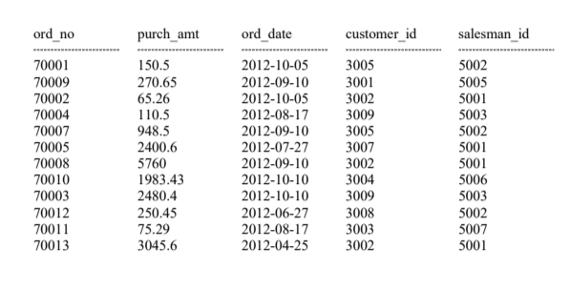

SELECT ord_no, ord_date, purch_amt

FROM orders

WHERE salesman_id = 5001;

20. From the following table, write an SQL query to select a range of products whose prices range from Rs.200 to Rs.600. Begin and end values are included. Return pro_id, pro_name, pro_price, and pro_com.

Sample table: item_mast

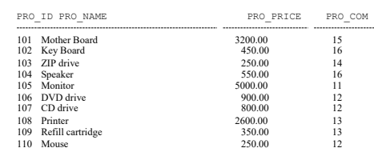

SELECT pro_id, pro_name, pro_price, pro_com

FROM item_mast

WHERE pro_price BETWEEN 200 AND 600;

21. From the following table, write a SQL query to calculate the average

price for a manufacturer code of 16. Return avg.

Sample table: item_mast

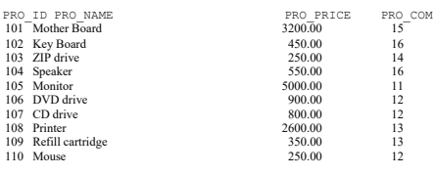

SELECT AVG(PRO_PRICE)

FROM item_mast

WHERE PRO_COM = 16;

22. From the following table, write a SQL query to display the pro_name as 'Item Name' and pro_priceas 'Price in Rs.'

Sample table: item_mast

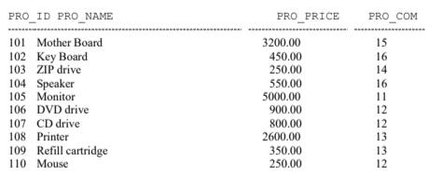

SELECT PRO_NAME AS 'Item Name', PRO_PRICE AS 'Price in Rs.'

FROM item_mast;

23. From the following table, write a SQL query to find the items whose prices are higher than or equal to $250. Order the result by product price in descending, then by product name in ascending. Return pro_name and pro_price.



SELECT pro_name, pro_price

FROM item_mast

WHERE pro_price >= 250

ORDER BY pro_price DESC, pro_name ASC;

24. From the following table, write an SQL query to calculate the average price of the items for each company. Return the average price and company code.



SELECT PRO_COM, AVG(PRO_PRICE) AS average_price

FROM your_table

GROUP BY PRO_COM;